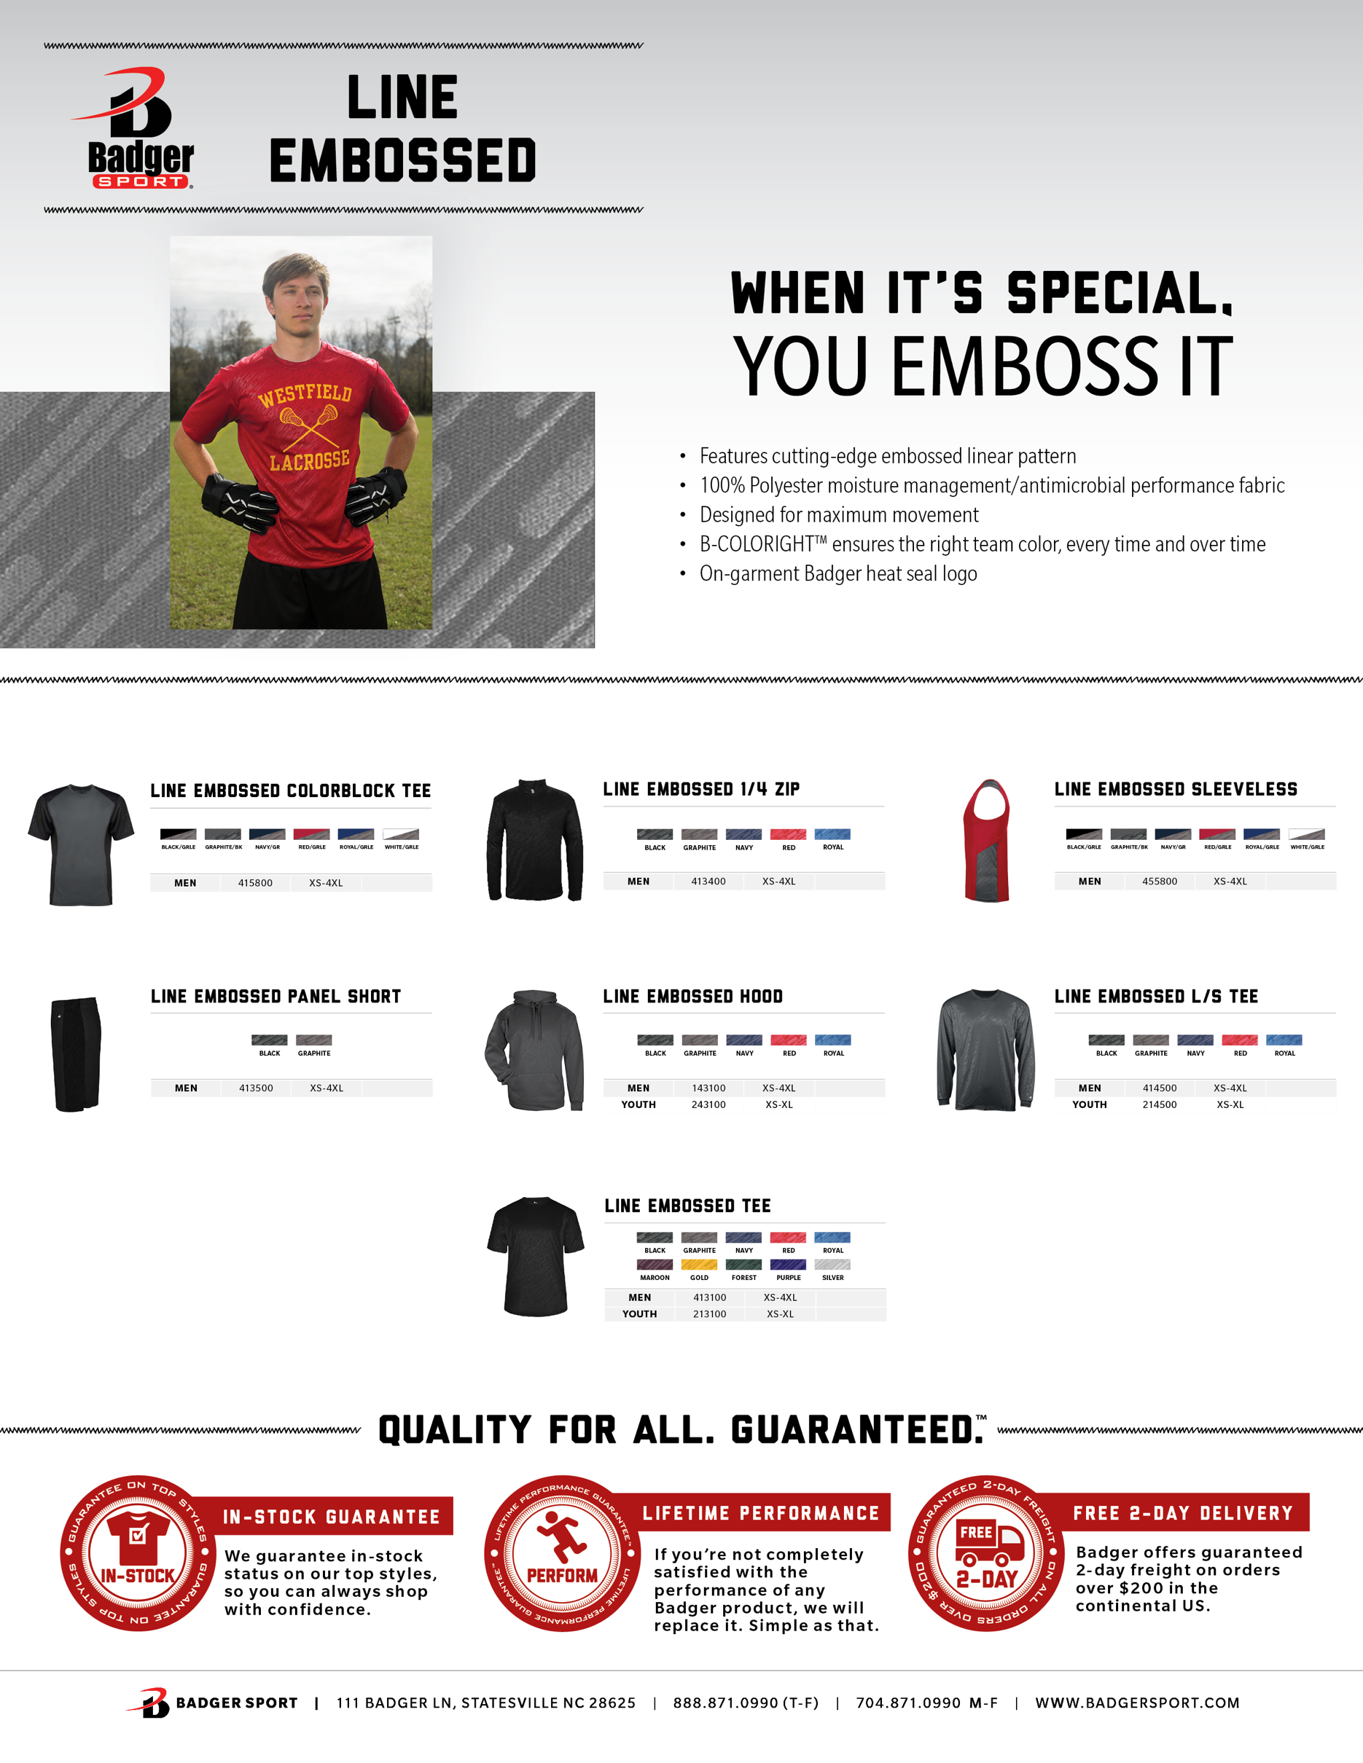

**ADD YOUR PRICING**

**ADD YOUR PRICING**

**ADD YOUR PRICING**

**ADD YOUR PRICING**

**ADD YOUR PRICING**

**ADD YOUR PRICING**

**ADD YOUR PRICING**

**ADD YOUR PRICING**

**ADD YOUR PRICING**

**ADD YOUR PRICING**